Project Design Phase-II Technology Stack (Architecture & Stack)

|  |  |
| --- | --- |
| Date | 13 October 2022 |
| Team ID | PNT2022TMID14269 |
| Project Name | University Admit Eligibility Predictor |
| Maximum Marks | 4 Marks |

Technical Architecture:

The Deliverable shall include the architectural diagram as below and the information as per the table1 & table 2

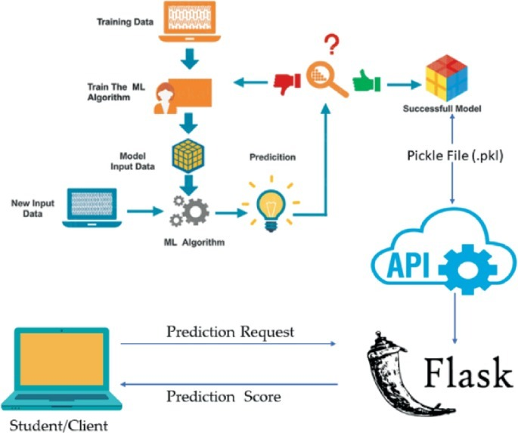

Table-1 : Components & Technologies:

|  |  |  |  |
| --- | --- | --- | --- |
| **S.No** | **Component** | **Description** | **Technology** |
| 1. | User Interface | How user interacts with application | HTML, CSS |
| 2. | Application Logic-1 | Logic for a process in the application | Python |
| 3. | Application Logic-2 | Logic for a process in the application | IBM Watson STT service |
| 4. | Application Logic-3 | Logic for a process in the application | IBM Watson Assistant |
| 5. | Database | Data Type (CSV FILE) | Kaggle website |
| 6. | Model of the data | Building model of the data | Machine learning |
| 7. | Libraries | Import libraries into data set | Pandas, Seaborn, Matplot lib, Numpy |
| 8. | Training and testing data | Purpose of data training and testing | Regression ,Classification, clustering Algorithms , SK learn |
| 9. | Testing Data | Tests data using Agile methodology | Agile methodology |
| 10. | Accuracy | Accuracy of the tested and trained data | Mean_squared_error, Mean_absolute_error |
| 11. | Infrastructure (Server ) | Application Deployment on Local System | Local. |

Table-2: Application Characteristics:

|  |  |  |  |
| --- | --- | --- | --- |
| **S.No** | **Characteristics** | **Description** | **Technology** |
| 1. | Open-Source Frameworks | List the open-source frameworks used | Flask framework |
| 2. | CSV file | Importing CSV file | Pandas |
| 3. | Data visualization | Perform data visualization | Matplot(pie charts,histograms) |

|  |  |  |  |
| --- | --- | --- | --- |
| **S.No** | **Characteristics** | **Description** | **Technology** |
| 4. | Testing and Training | Create testing and training for the dataset | Technology used standardScaler, MinMaxScaler |
| 5. | Performance | Design consideration for the performance of the application | Technology used IBM wastson |

References:

<https://c4model.com/>

<https://developer.ibm.com/patterns/online-order-processing-system-during-pandemic/> <https://www.ibm.com/cloud/architecture>

<https://aws.amazon.com/architecture>